Objective 1: Container Networking with Open vSwitch and SDN Controllers

Introduction
This tutorial provides a step-by-step guide to setting up container networking using Docker, Open vSwitch (OVS), and the Ryu SDN controller. It covers three configurations:
- Section 1: Default Docker bridge networking
- Section 2: Open vSwitch with an SDN controller running inside a container
- Section 3: Open vSwitch with an SDN controller running on the host
This guide assumes a 24.04 server with Docker and Open vSwitch installed.

Note on Python Version Compatibility
By default, Ubuntu 24.04 ships with Python 3.12, which is incompatible with Ryu due to deprecations in distutils and changes in eventlet. To successfully install and run Ryu, Python must be downgraded to 3.9. Follow these steps to install and configure Python 3.9 on Ubuntu 24.04:

Step 1: Add the Deadsnakes PPA (For Older Python Versions)
sudo apt update
sudo apt install -y software-properties-common
sudo add-apt-repository -y ppa:deadsnakes/ppa
sudo apt update

Step 2: Install Python 3.9
sudo apt install -y python3.9 python3.9-venv python3.9-dev

Verify the installation:
python3.9 --version

Step 3: Create a Python 3.9 Virtual Environment
python3.9 -m venv ryu-venv-py39
source ryu-venv-py39/bin/activate

Step 4: Install Ryu Dependencies and Ryu
pip install --upgrade pip
pip install setuptools wheel eventlet==0.30.2
pip install ryu

Step 5: Run Ryu with Python 3.9
ryu-manager --version
If Ryu runs successfully, it is now using Python 3.9 instead of Python 3.12.

Section 1: Container Networking Using the Default Docker Bridge

Step 1: Install Docker
sudo apt update
sudo apt install -y docker.io

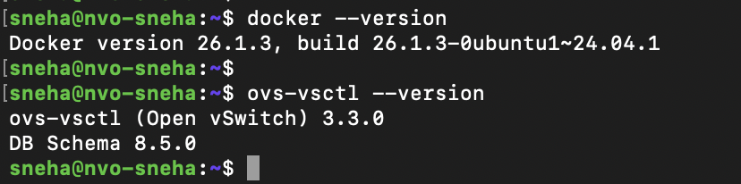

Step 2: Pull the Debian Image
sudo docker pull debian

Step 3: Create Two Containers
sudo docker run -dit --name container1 debian bash
sudo docker run -dit --name container2 debian bash

Step 4: Check Container IP Addresses
sudo docker inspect -f '{{range.NetworkSettings.Networks}}{{.IPAddress}}{{end}}' container1
sudo docker inspect -f '{{range.NetworkSettings.Networks}}{{.IPAddress}}{{end}}' container2

Step 5: Test Connectivity Between Containers
sudo docker exec -it container1 ping -c 3 <container2_IP>
If the ping is successful, the containers can communicate over Docker's default bridge.
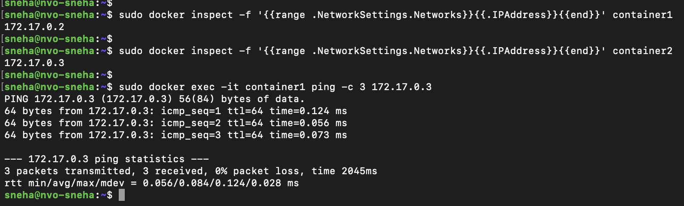

Section 2: Container Networking Using Open vSwitch and a Containerized SDN Controller

Step 1: Install Open vSwitch
sudo apt install -y openvswitch-switch

Step 2: Create an Open vSwitch Bridge
sudo ovs-vsctl add-br br0

Step 3: Attach Containers to the OVS Bridge
sudo ovs-docker add-port br0 eth1 container1 --ipaddress=192.168.1.2/24
sudo ovs-docker add-port br0 eth1 container2 --ipaddress=192.168.1.3/24

Step 4: Deploy the Ryu SDN Controller in a Container
sudo docker run -dit --name ryu --net=host osrg/ryu

Step 5: Start Ryu's L2 Learning Switch
sudo docker exec -it ryu ryu-manager ryu.app.simple_switch_13
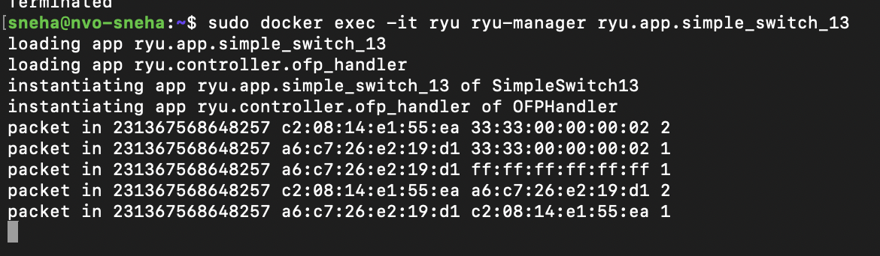

Step 6: Connect OVS to the Controller
sudo ovs-vsctl set-controller br0 tcp:127.0.0.1:6633

Step 7: Verify Container Connectivity
sudo docker exec -it container1 ping -c 3 192.168.1.3
If the ping works, OVS is successfully forwarding packets based on SDN logic.
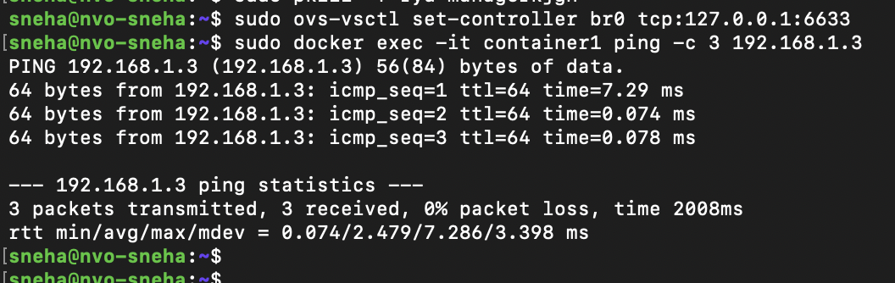

Section 3: Container Networking Using Open vSwitch and an SDN Controller on the Host

Step 1: Remove the Containerized Ryu Controller
sudo docker stop ryu
sudo docker rm ryu

Step 2: Install Ryu on the Host
sudo apt install -y python3-pip
pip3 install --upgrade pip
pip3 install ryu

Step 3: Start Ryu on the Host
ryu-manager ryu.app.simple_switch_13

To run it in the background:
nohup ryu-manager ryu.app.simple_switch_13 &

Step 4: Connect OVS to the Host-Based Controller
sudo ovs-vsctl set-controller br0 tcp:127.0.0.1:6633

Step 5: Verify Container Connectivity
sudo docker exec -it container1 ping -c 3 192.168.1.3

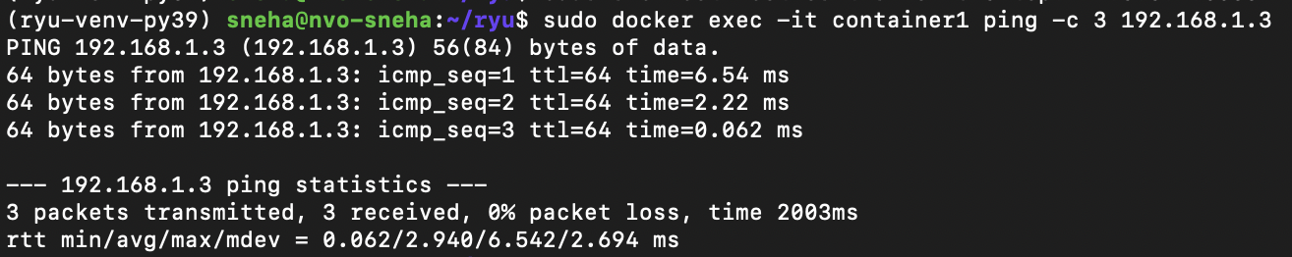

Step 6: View Ryu Logs
tail -f nohup.out
If packets appear in the logs, the SDN controller is actively processing flows.
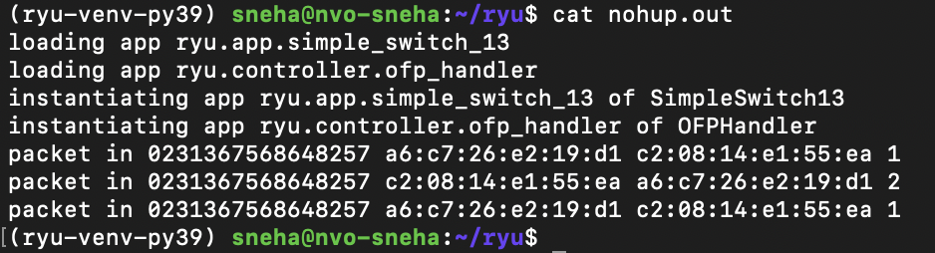

Conclusion
This tutorial demonstrates how to set up container networking using Docker, Open vSwitch, and Ryu SDN in three different configurations. Each method provides different levels of flexibility and control over how traffic is managed.
For advanced setups, you can experiment with VXLAN overlays, multiple OVS bridges, and additional SDN applications in Ryu.

Objective 2: VXLAN-Based Container Networking Across VMs

Introduction
In this objective, I set up VXLAN-based container networking between two VMs. This allowed containers running on different VMs to communicate as if they were on the same Layer 2 network.

Section 1: Configuring VXLAN Between VMs
I am using my Dell physical server for this setup as well. I am using Openstack to create 2 debian VMs.

Step 1: Checking VM IP Addresses
First, I determined the IP addresses of both VMs using:
ip a | grep eth0
- VM1: eth0: 172.24.4.75
- VM2: eth0: 172.24.4.49

Step 2: Creating a VXLAN Bridge
On both VMs, I created a VXLAN bridge:
sudo ip link add br-vxlan type bridge
sudo ip link set br-vxlan up

Step 3: Creating a VXLAN Interface

On VM1 (172.24.4.75)
sudo ip link add vxlan0 type vxlan id 42 dev eth0 remote 172.24.4.49 dstport 4789
sudo ip link set vxlan0 up
sudo ip link set vxlan0 master br-vxlan
sudo ip addr add 10.10.20.1/24 dev br-vxlan

On VM2 (172.24.4.49)
sudo ip link add vxlan0 type vxlan id 42 dev eth0 remote 172.24.4.75 dstport 4789
sudo ip link set vxlan0 up
sudo ip link set vxlan0 master br-vxlan
sudo ip addr add 10.10.20.2/24 dev br-vxlan

Step 4: Testing VXLAN Connectivity
To verify that VXLAN was working, I ran:
ping -c 3 10.10.20.2 # From VM1
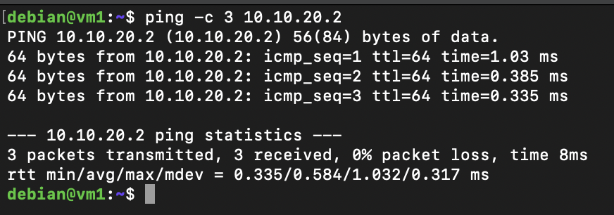
ping -c 3 10.10.20.1 # From VM2
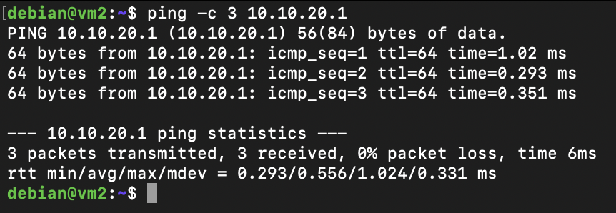
The pings were successful, confirming that VXLAN was correctly set up.

Section 2: Deploying Containers on VXLAN

Step 1: Starting Containers Without Networking
I created two Debian containers without default networking:

On VM1
sudo docker run -dit --name container1 --net=none --privileged debian bash
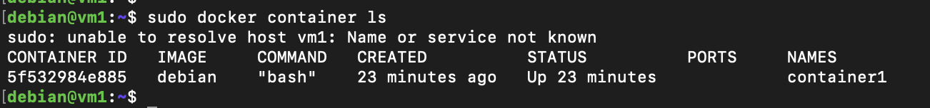

On VM2
sudo docker run -dit --name container2 --net=none --privileged debian bash
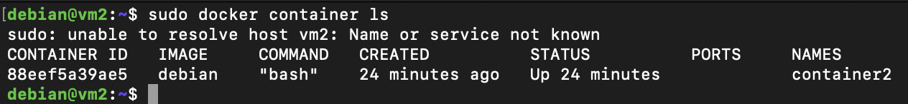

Step 2: Creating Virtual Ethernet (veth) Pairs
To connect the containers to VXLAN, I set up veth pairs.

On VM1
sudo ip link add veth1 type veth peer name veth1-br
sudo ip link set veth1 netns $(docker inspect -f '{{.State.Pid}}' container1)
sudo ip link set veth1-br master br-vxlan
sudo ip link set veth1-br up

On VM2
sudo ip link add veth2 type veth peer name veth2-br
sudo ip link set veth2 netns $(docker inspect -f '{{.State.Pid}}' container2)
sudo ip link set veth2-br master br-vxlan
sudo ip link set veth2-br up

Step 3: Assigning IP Addresses to Containers

On VM1 (container1)
sudo docker exec -it container1 ip link set dev veth1 up
sudo docker exec -it container1 ip addr add 10.10.10.1/24 dev veth1

On VM2 (container2)
sudo docker exec -it container2 ip link set dev veth2 up
sudo docker exec -it container2 ip addr add 10.10.10.2/24 dev veth2

Step 4: Testing Container-to-Container Connectivity
To confirm that the containers could communicate, I ran:

From container1 on VM1
sudo docker exec -it container1 ping -c 3 10.10.10.2
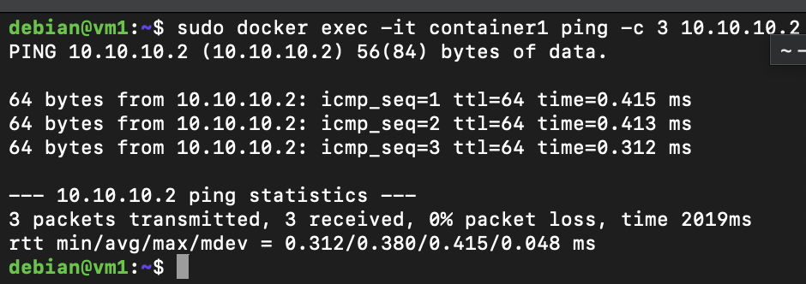

From container2 on VM2
sudo docker exec -it container2 ping -c 3 10.10.10.1
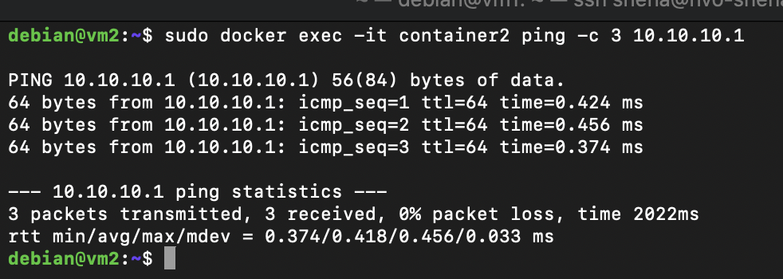
The pings were successful, proving that VXLAN-based container networking was functional.

Section 3: Verifying VXLAN Encapsulation

Step 1: Capturing VXLAN Traffic with tcpdump
To confirm VXLAN encapsulation, I ran tcpdump on VM2 while sending pings from container1.

On VM2 (172.24.4.49)
sudo tcpdump -i eth0 port 4789

Step 2: Generating Container Traffic
From container1, I ran:
sudo docker exec -it container1 ping -c 5 10.10.10.2
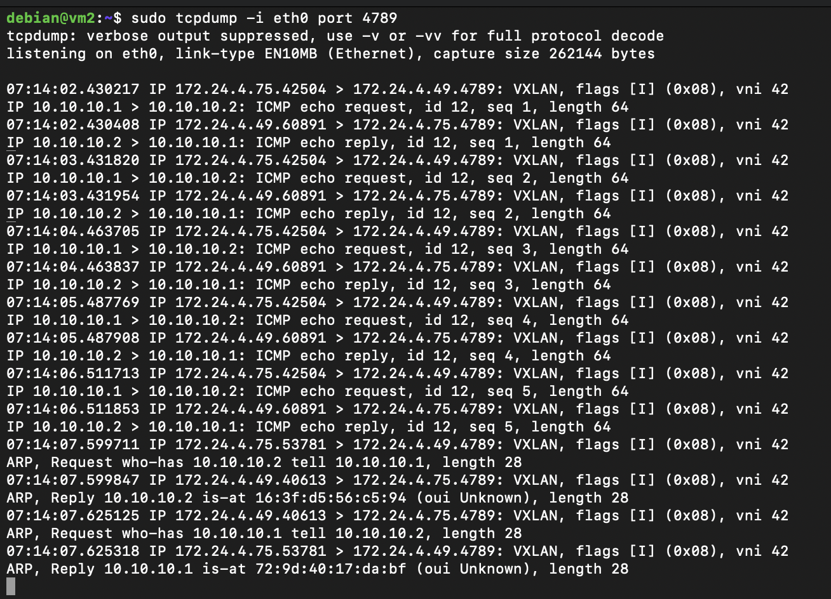
The tcpdump output showed VXLAN-encapsulated packets, confirming that the network overlay was working.

Step 3: Inspecting VXLAN Tunnel Details
I checked the VXLAN interface details:
ip -d link show vxlan0
The output confirmed that VXLAN ID (VNI) = 42, encapsulation was happening over UDP port 4789, and traffic was successfully routed through VXLAN.

Conclusion
In this setup, I:
- Created a VXLAN tunnel between VMs
- Attached containers to the VXLAN bridge
- Verified VXLAN encapsulation using tcpdump

